Dashboard 1: (Global Arms Trade)
4
3
2
1
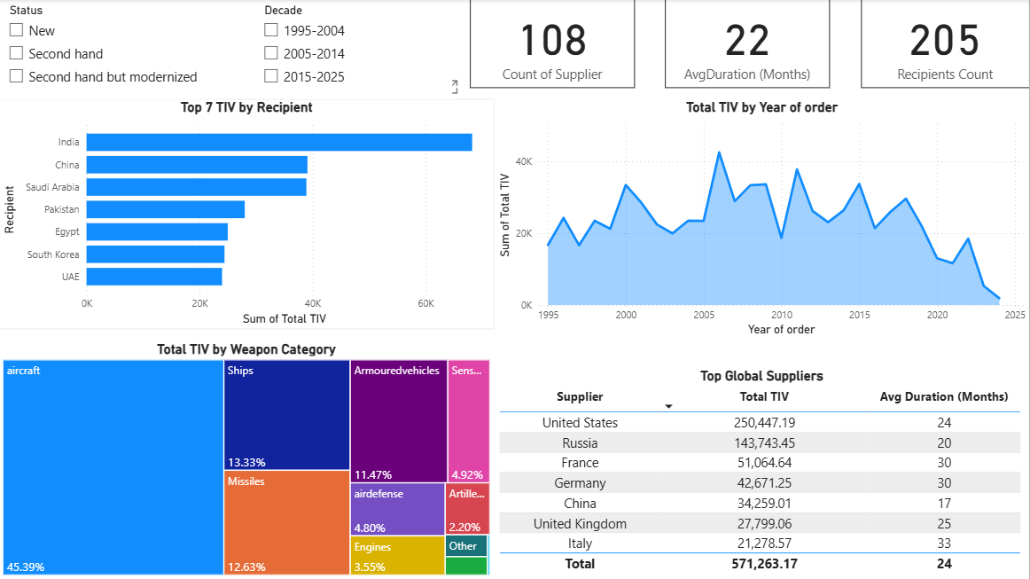
5
General insights about the world trade and compare them with Saudi Arabia.

Chart 1:
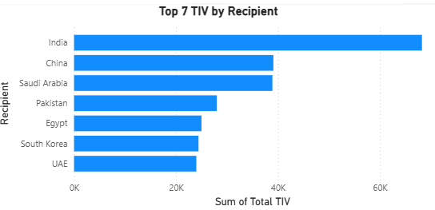
Top 7 Weapons Recipients chart shows a significant gap between India and China by 43%.
Saudi Arabia follows closely to China and that a strong indicator given the major differences in their economy, population, and area

Metric | China | Saudi Arabia
GDP (Nominal, 2023) | 17.79 trillion USD | 1.07 trillion USD
Country Area | 9,600,000 km² | 2,150,000 km²
Population (2023) | 1.41 billion | 36 million

Chart 2:
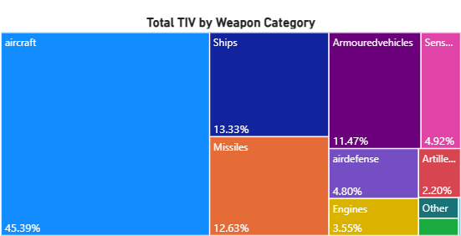

The map shows that most countries focus on exporting aircraft, 45.4% of total exports. This reflects the high strategic and financial value of aircraft in modern defense operations

Chart 3:
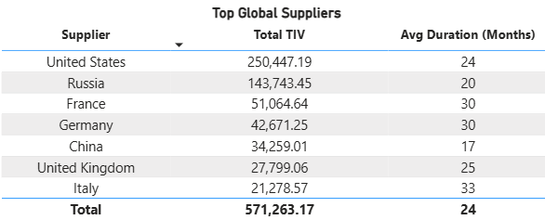

Top global suppliers with average delivery time indicate supplier speed and reliability.

Chart 4:
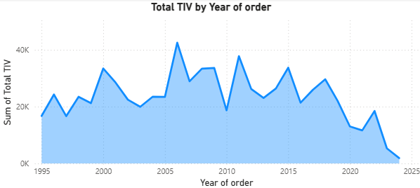

The oscillation in the line every 3 years is because countries wait to receive their orders, which take an average of 22 months to prepare, before ordering new ones. This indicates active demand until 2020, when COVID-19 affected the process.

